St. Francis Institute of Technology, Mumbai-400 103

**Department Of Information Technology**

A.Y. 2024-2025

Class: TE-ITA/B, Semester: V

Subject: **DevOps Lab**

**Experiment – 4: To understand Continuous Integration, install and configure Jenkins with Maven/Ant/Gradle to setup a build Job.**

1. **Aim:** To understand Continuous Integration, install and configure Jenkins with Maven
2. **Objectives:** Aim of this experiment is that, the students will be able

* To Integrate and deploy tools like Jenkins and Maven, which is used to build

applications in DevOps environment

1. **Outcomes:** After study of this experiment, the students will be able

* To understand the importance of Jenkins to Build and deploy Software

Applications on server environment.

* Learn about Jenkins (With Architecture)
* To have introduction to Maven / Gradle / Ant

1. **Prerequisite:** Knowledge of software engineering concept of integration
2. **Requirements:** Jenkins,JDK, python, ANT,Personal Computer, Windows operating system, browser, Internet Connection, Microsoft Word.
3. **Pre-Experiment Exercise:**

**Brief Theory:** Refer shared material

1. **Laboratory Exercise**
   * + 1. **Procedure:**

**a. Answer the following:**

* What is Jenkins?

**Jenkins** is an open-source automation server used primarily for continuous integration and continuous delivery (CI/CD) in software development. It automates the building, testing, and deployment of applications, helping developers integrate changes to projects more frequently.

* Why use Jenkins?

**Automation:** Automates repetitive tasks, reducing manual intervention.

**Continuous Integration/Delivery:** Facilitates frequent code integration and deployment, ensuring faster release cycles.

**Extensibility:** Supports numerous plugins, making it adaptable to various development and deployment environments.

**Scalability:** Easily scales to handle large and complex projects with distributed builds across multiple machines.

**b**. **Execute following (Refer the shared material) and attach screenshots:**

* Install Jenkins
* Configure Jenkins with Maven and ANT
* Build 4 basic projects in Jenkins

1. **Post-Experiments Exercise**
2. **Extended Theory:**

Nil

1. **Questions:**

* What are the system requirements to install Jenkins?
* Give some important plugins in Jenkins.
* What is Maven and ANT?

1. **Conclusion:**

* Write what was performed in the experiment.
* Write the significance of the topic studied in the experiment.

1. **References:**

<https://jenkins.io/doc/>

<https://www.cloudbees.com/jenkins/what-is-jenkins>

<https://vmokshagroup.com/blog/what-is-jenkins/>

<https://www.infoworld.com/article/3239666/what-is-jenkins-the-ci-server-explained.html>

<https://hackr.io/blog/jenkins-interview-questions>

<https://www.edureka.co/blog/interview-questions/jenkins-interview-questions/>

• Install Jenkins

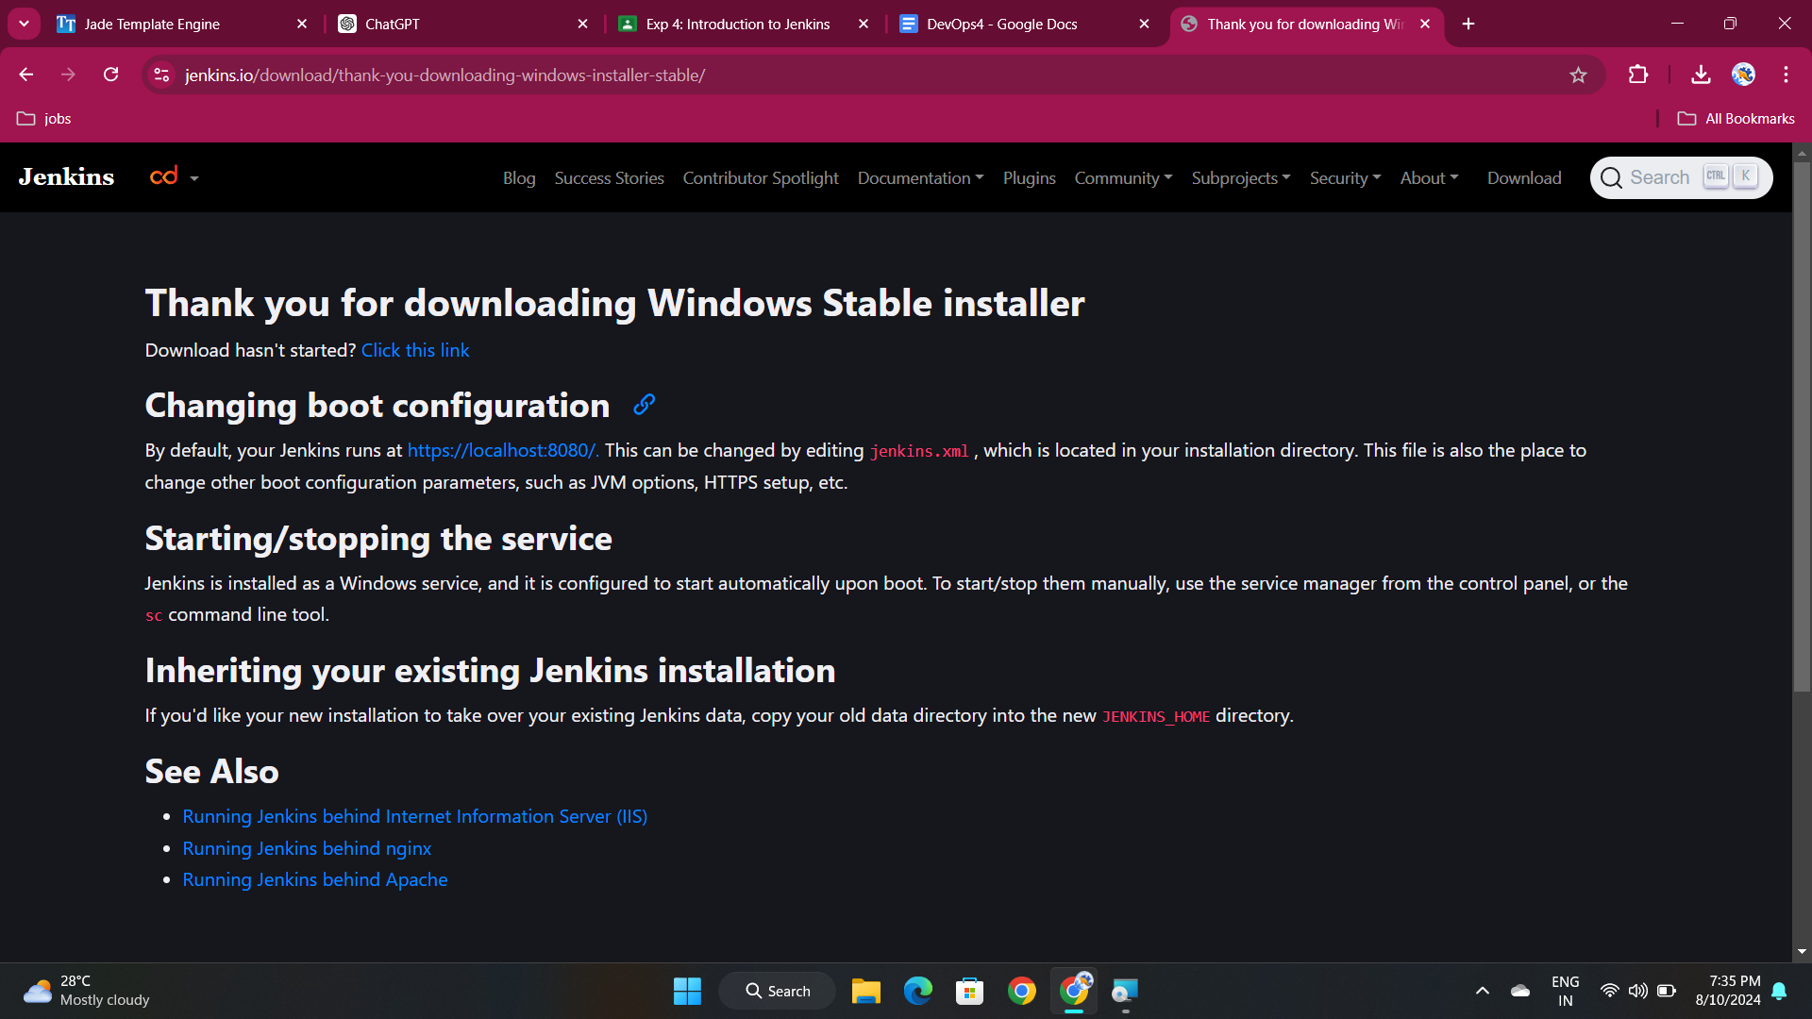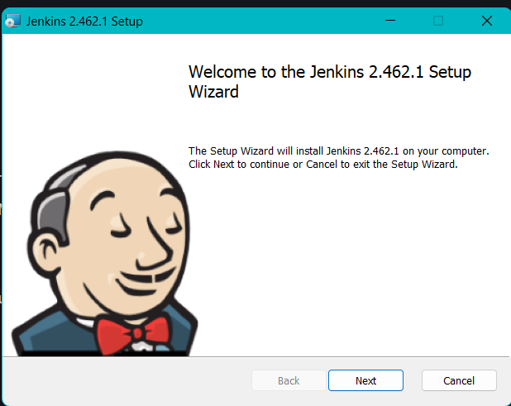

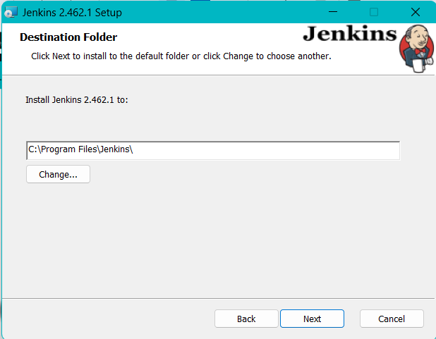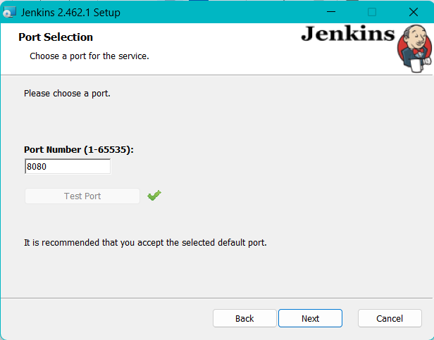

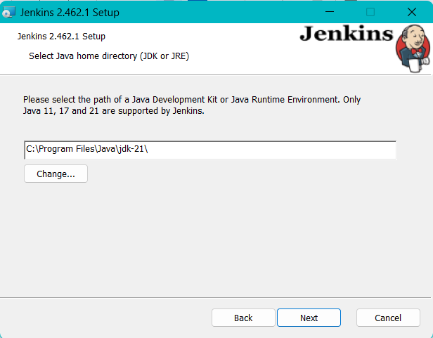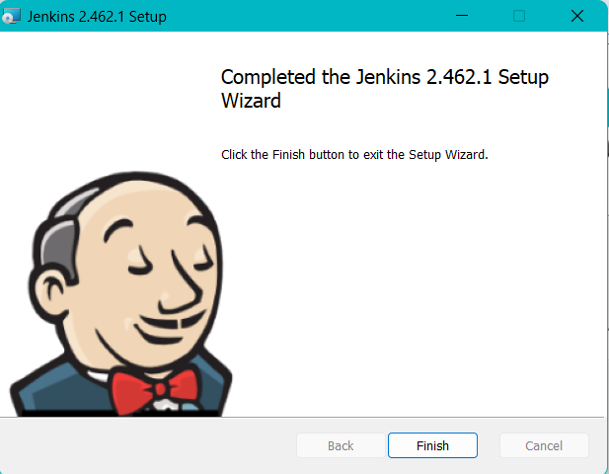

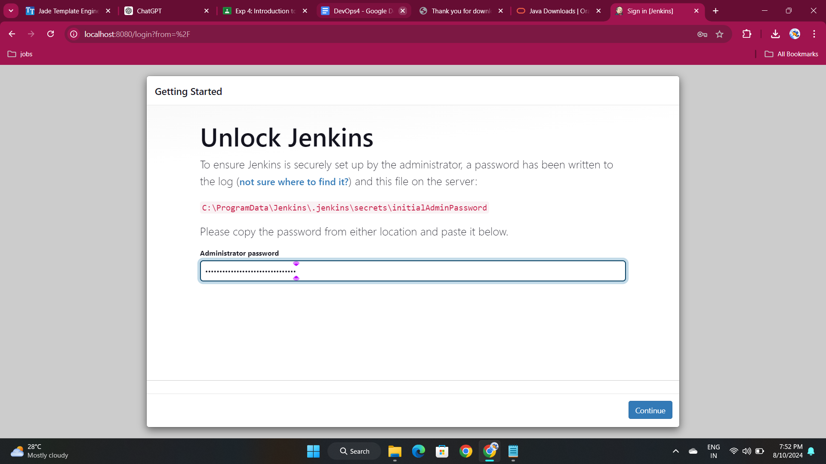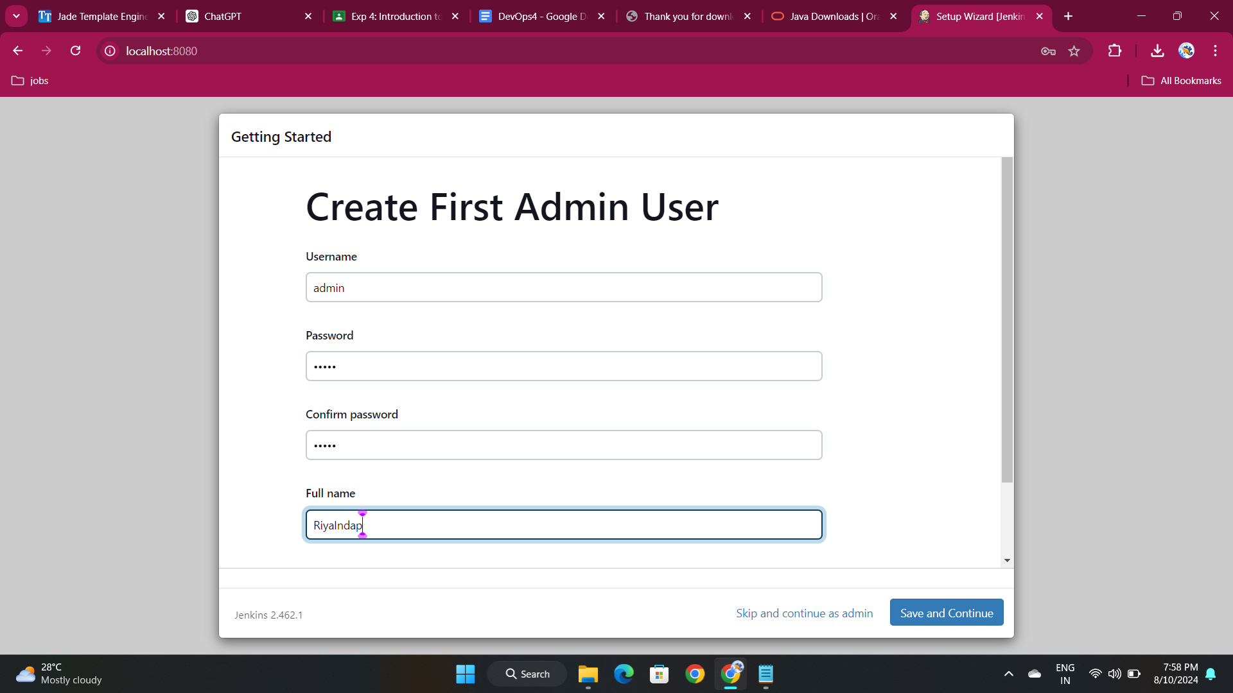

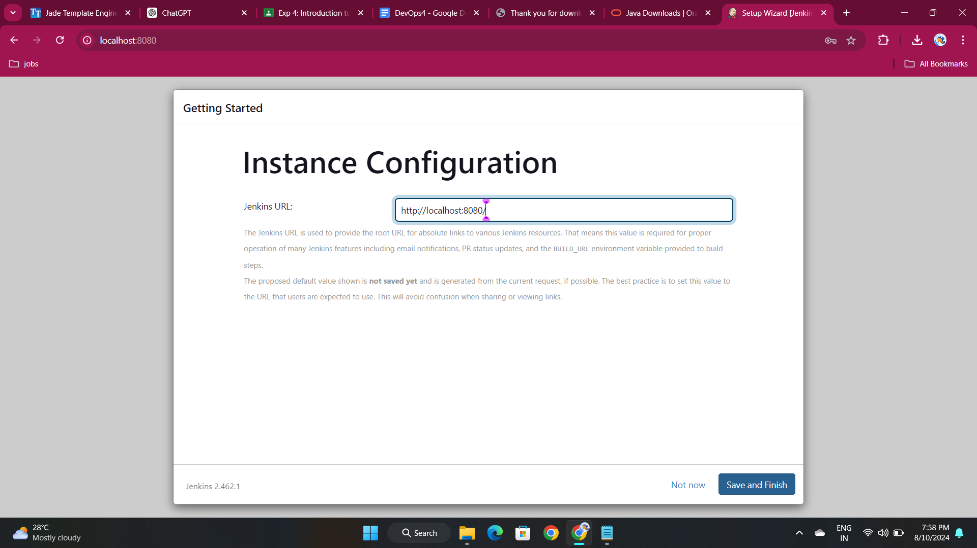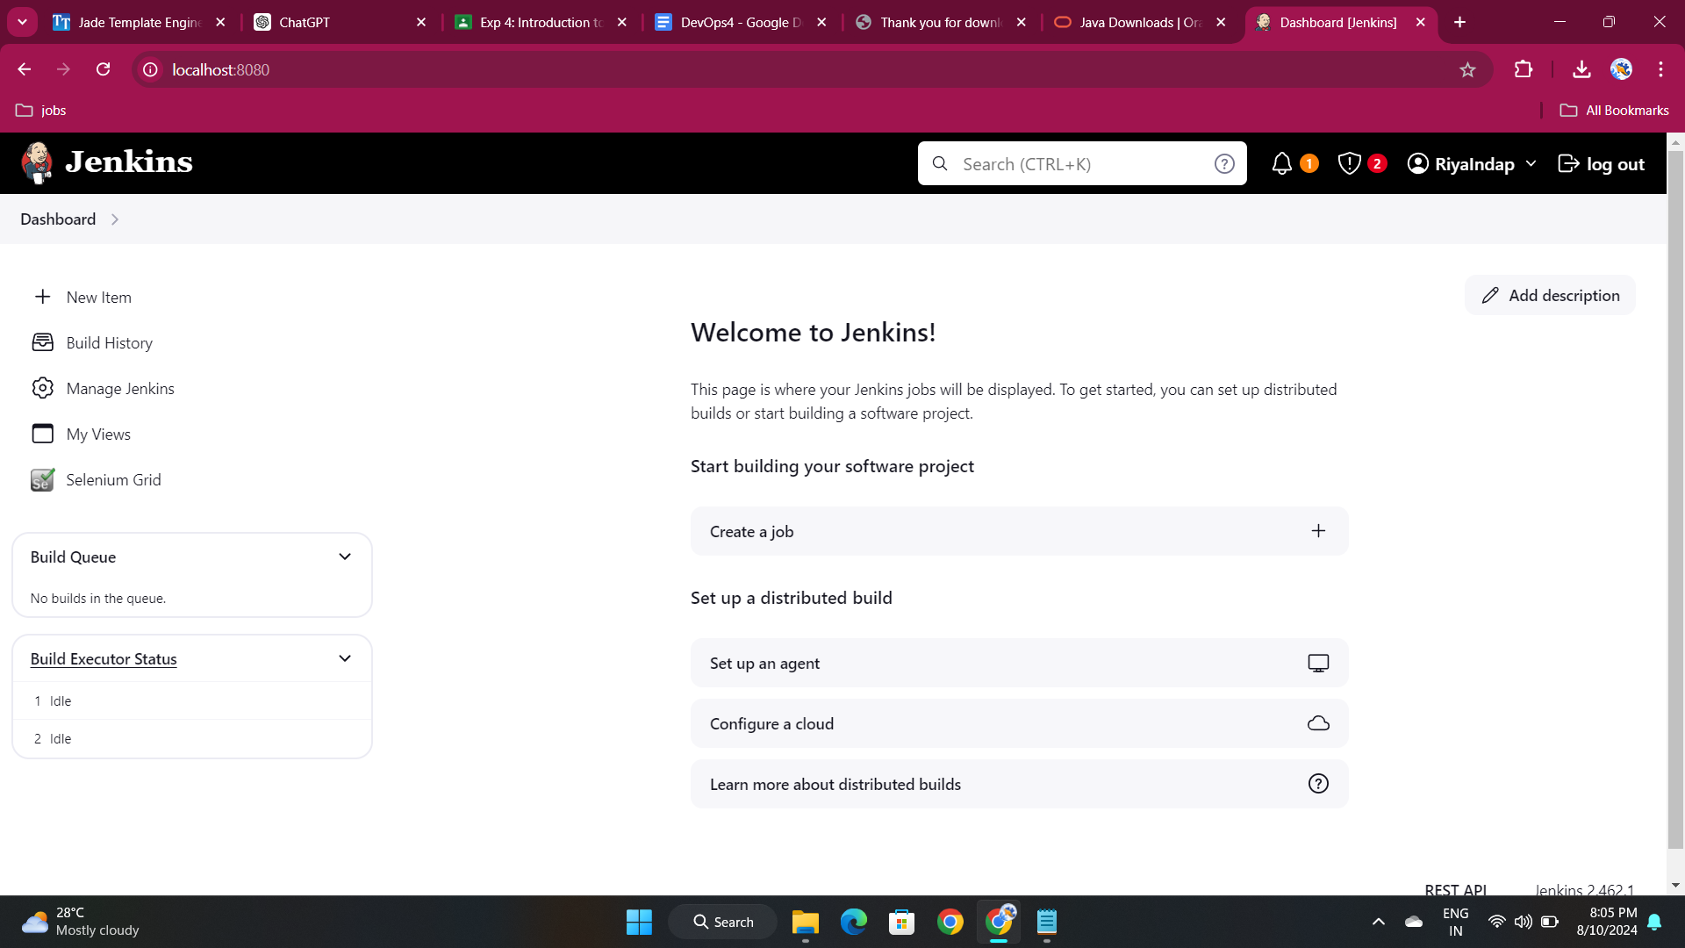

Managing Plugins

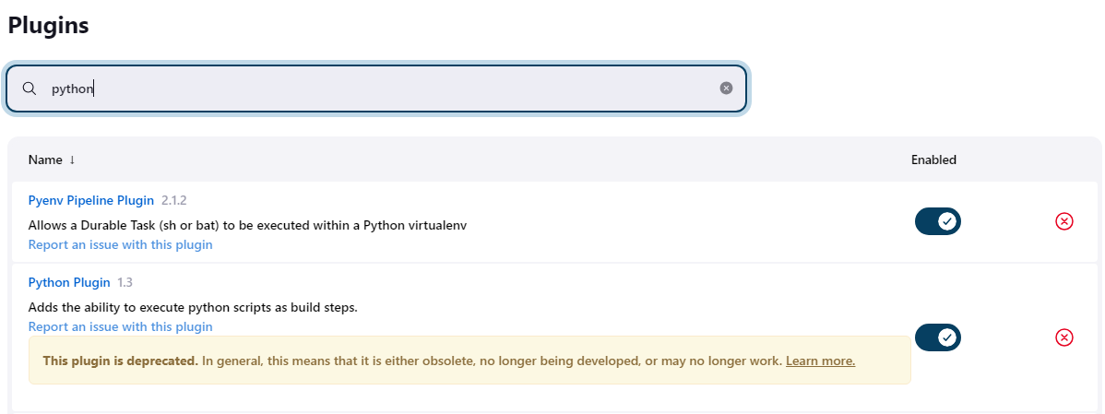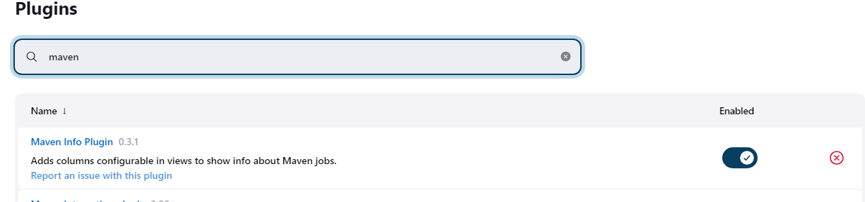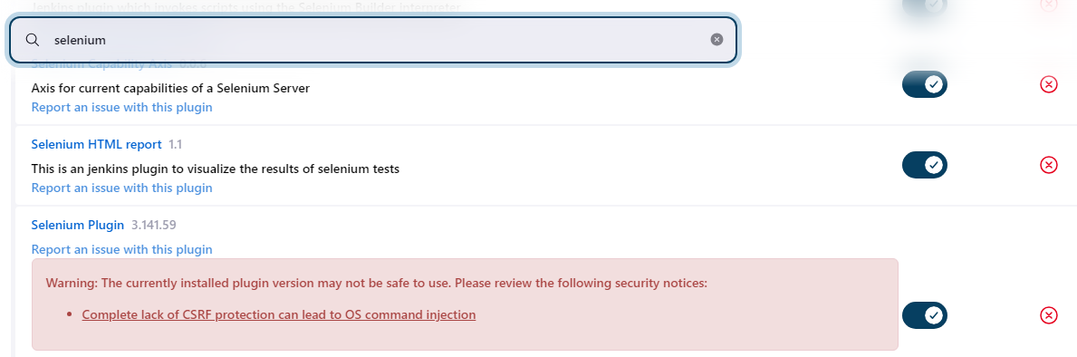

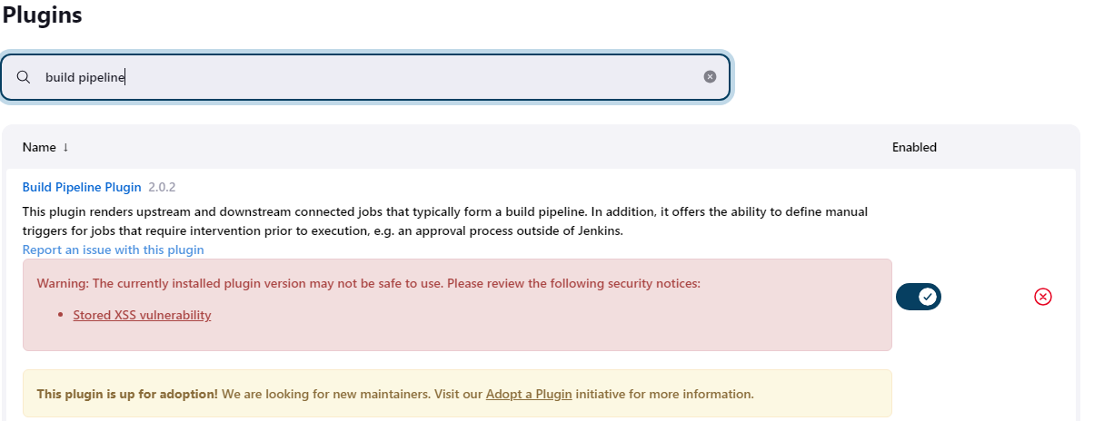

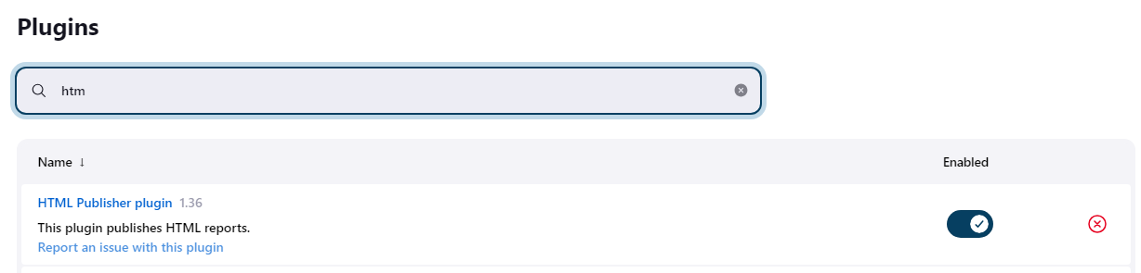

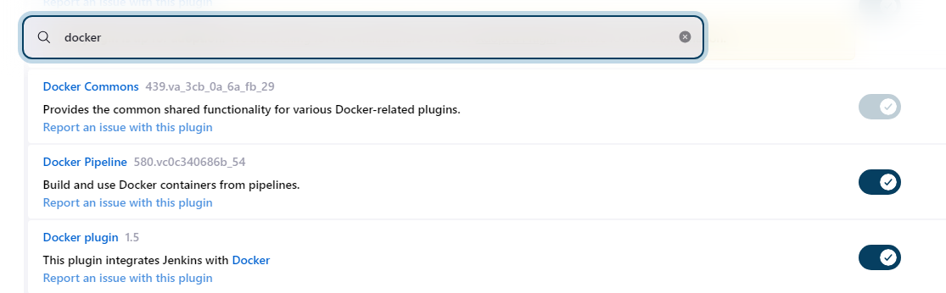

Tools to configure:

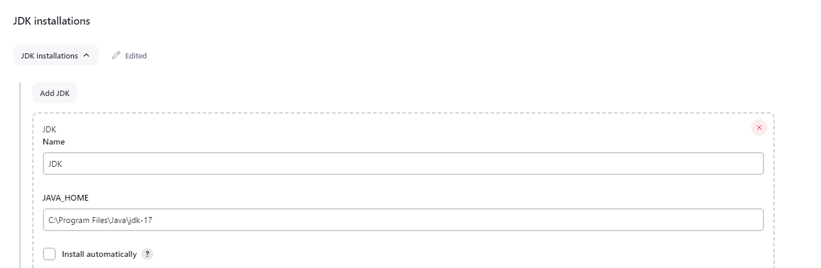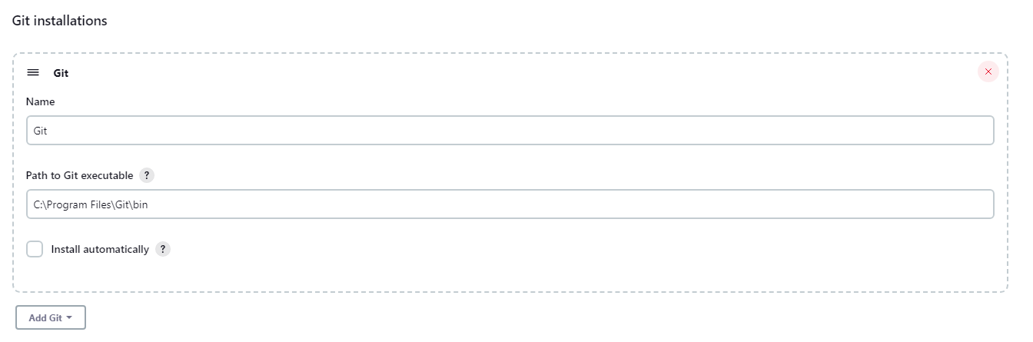

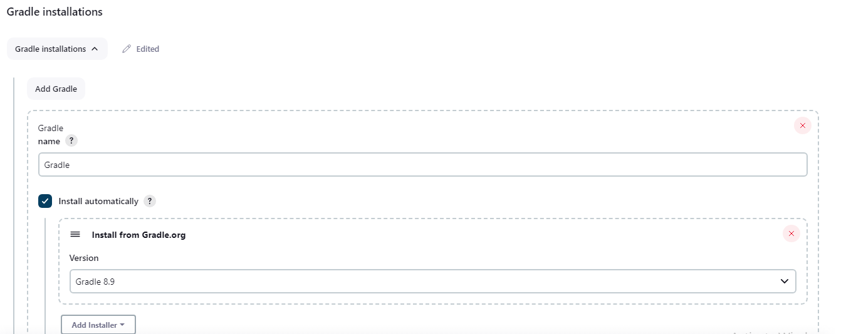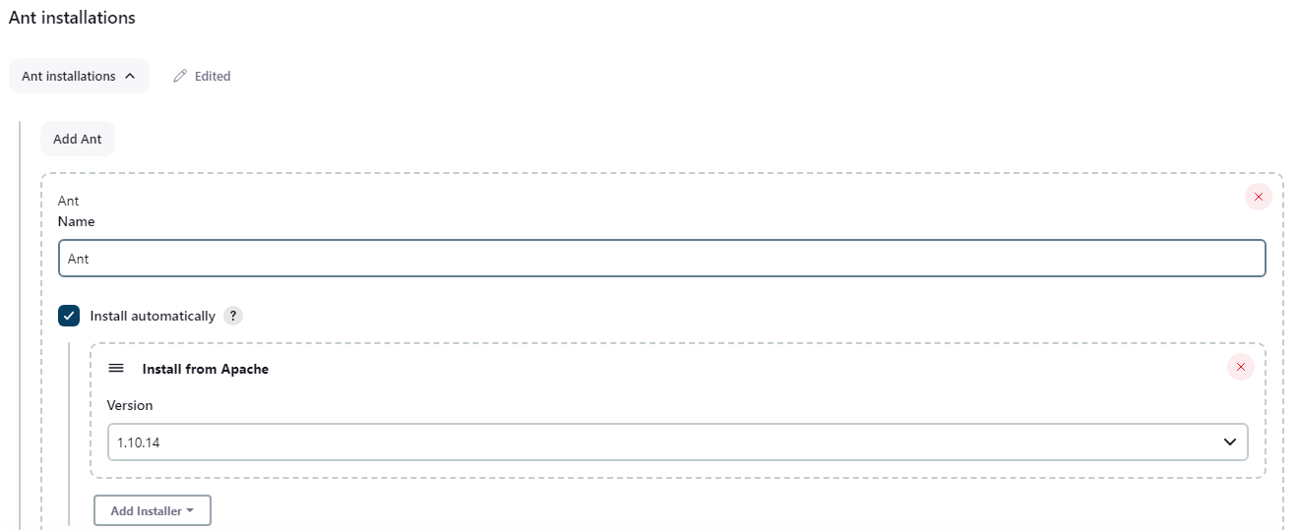

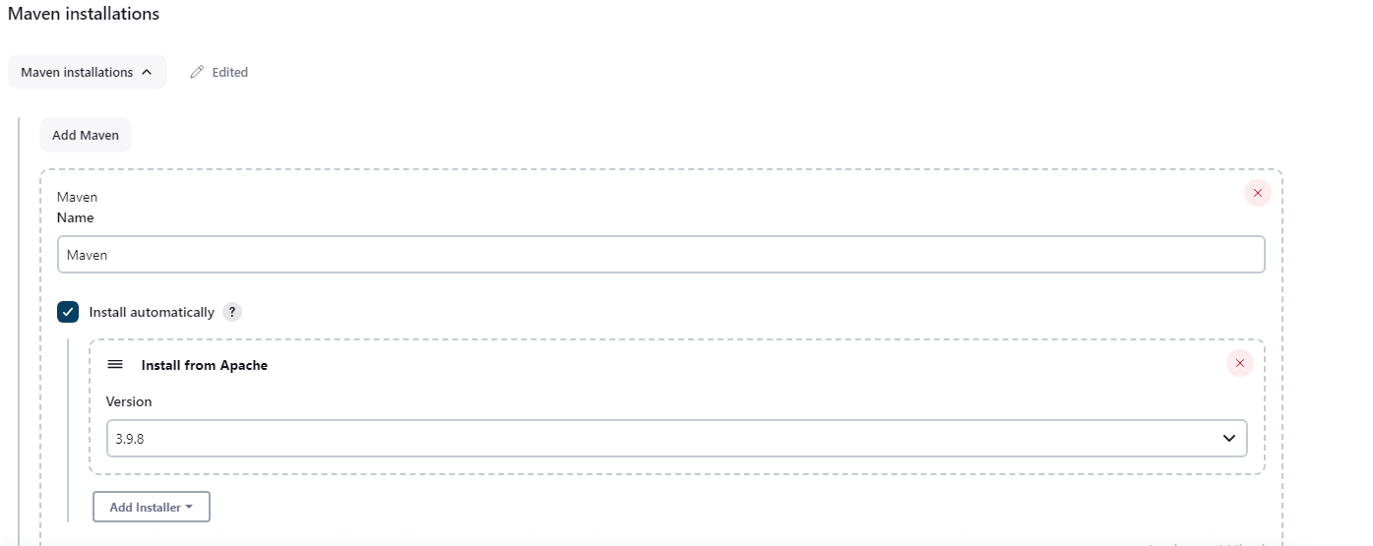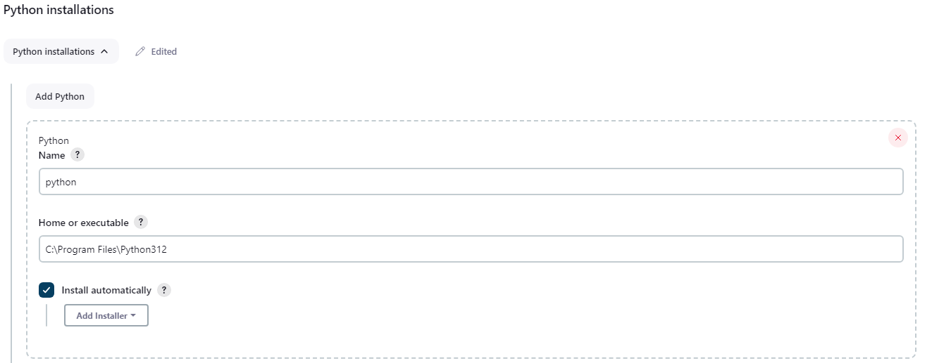

• Build jobs in Jenkins

1. Freestyle project (Simple Windows batch command) – echo:

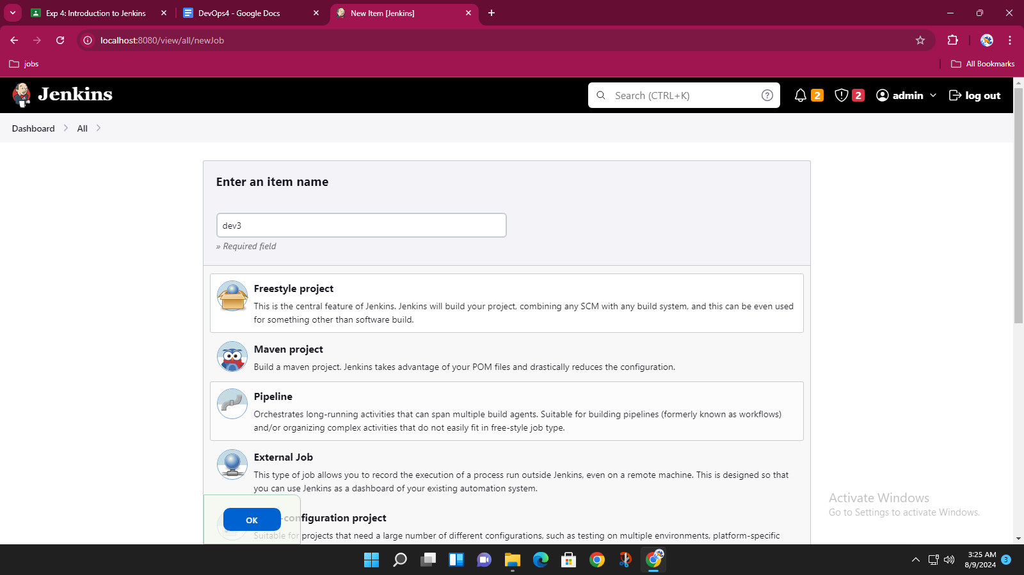

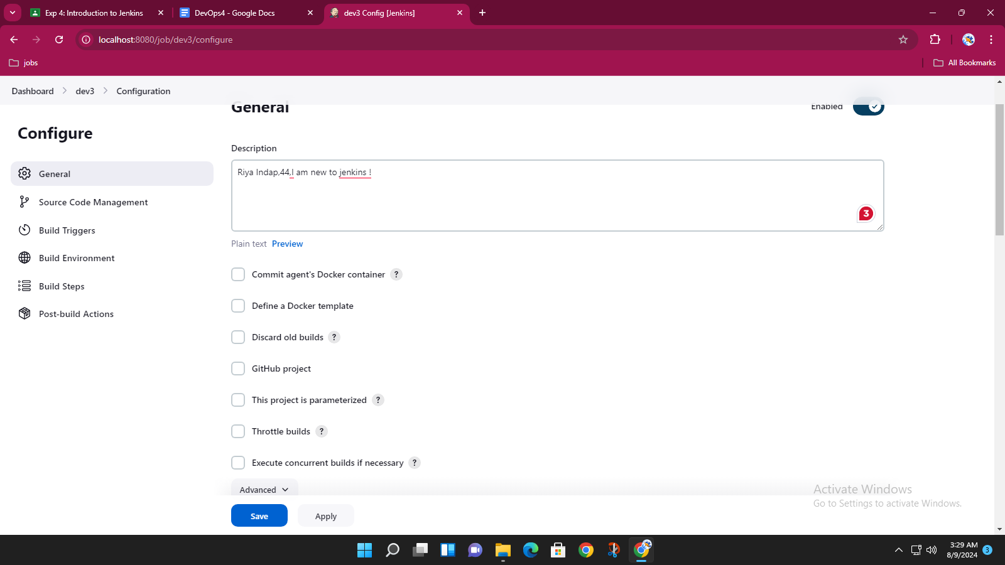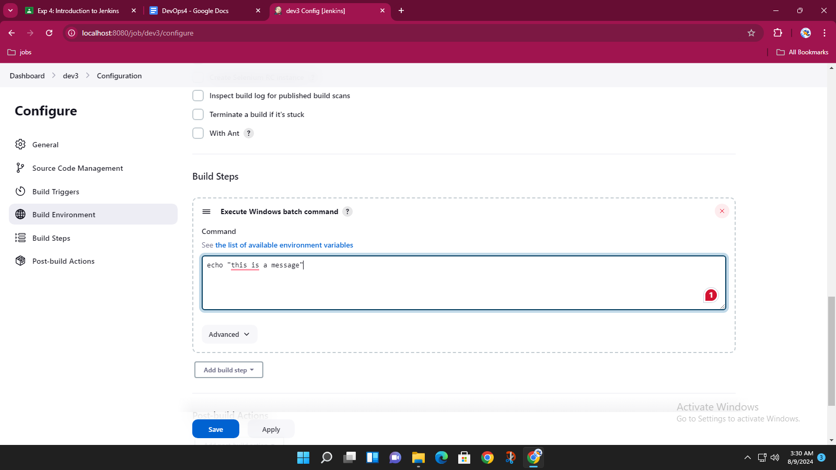

after saving on dashboard do build now, then in that build

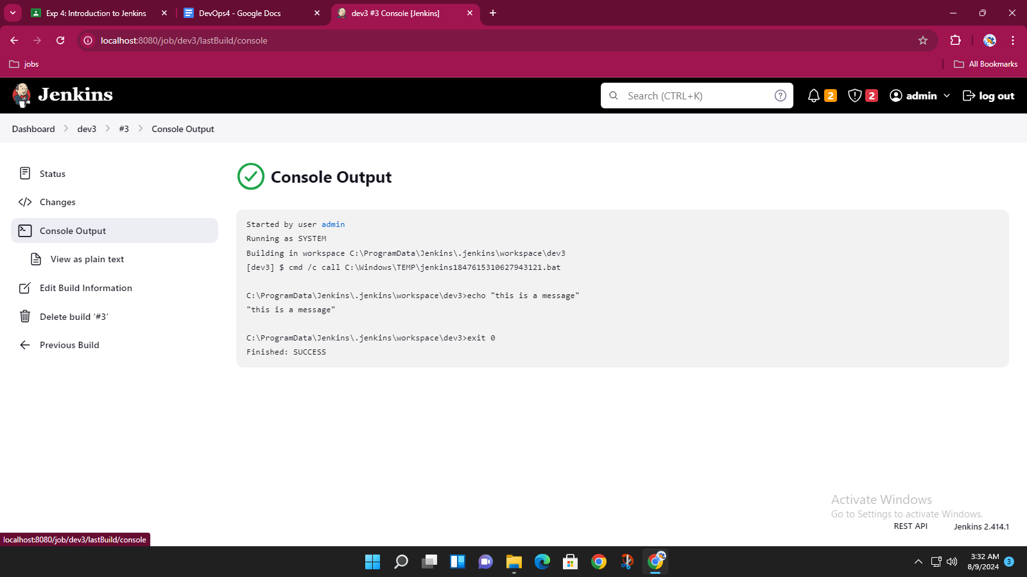

2. Freestyle parameterized project (Windows batch command) –string,

Boolean and choice parameters with echo

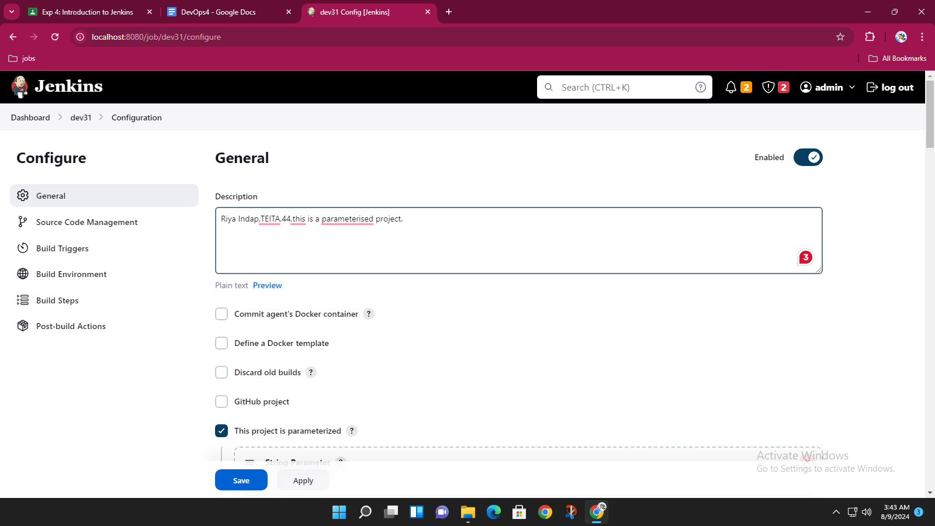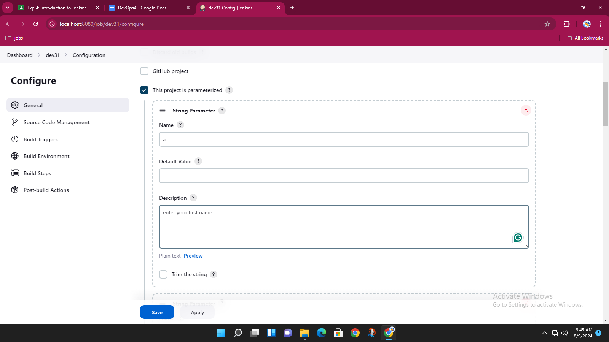

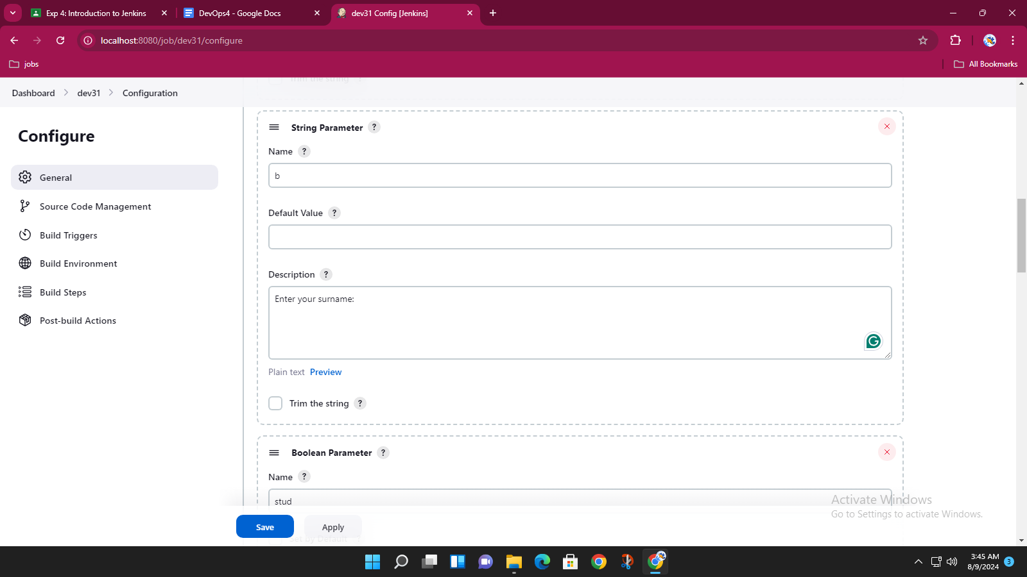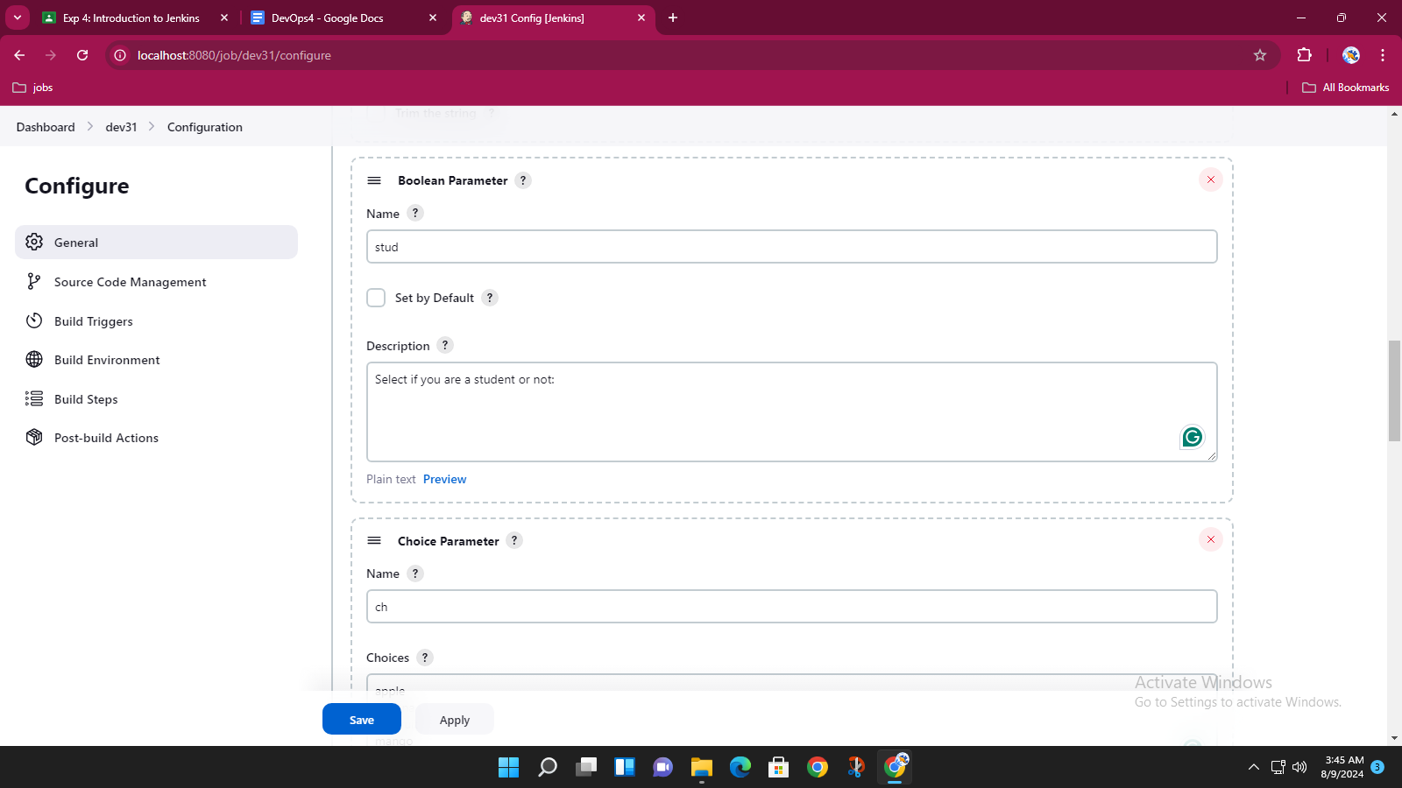

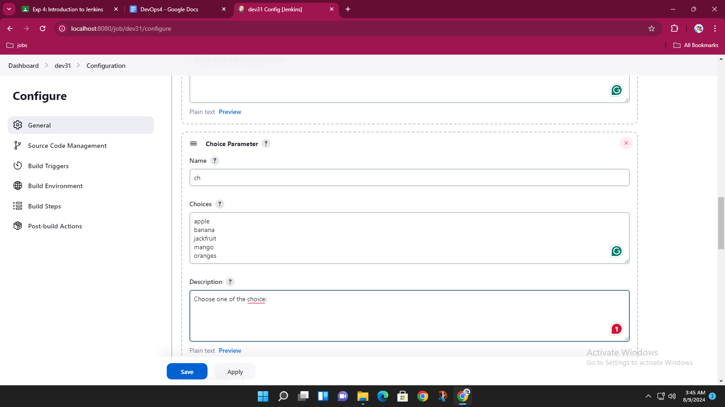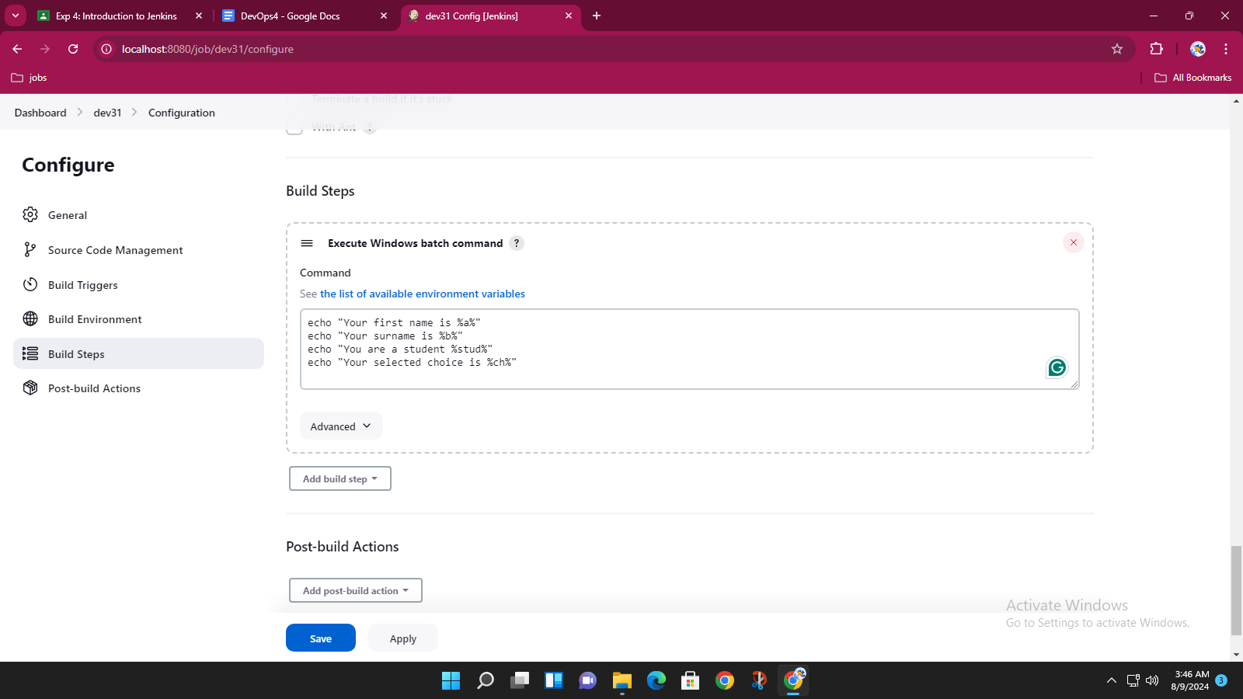

build with parameters

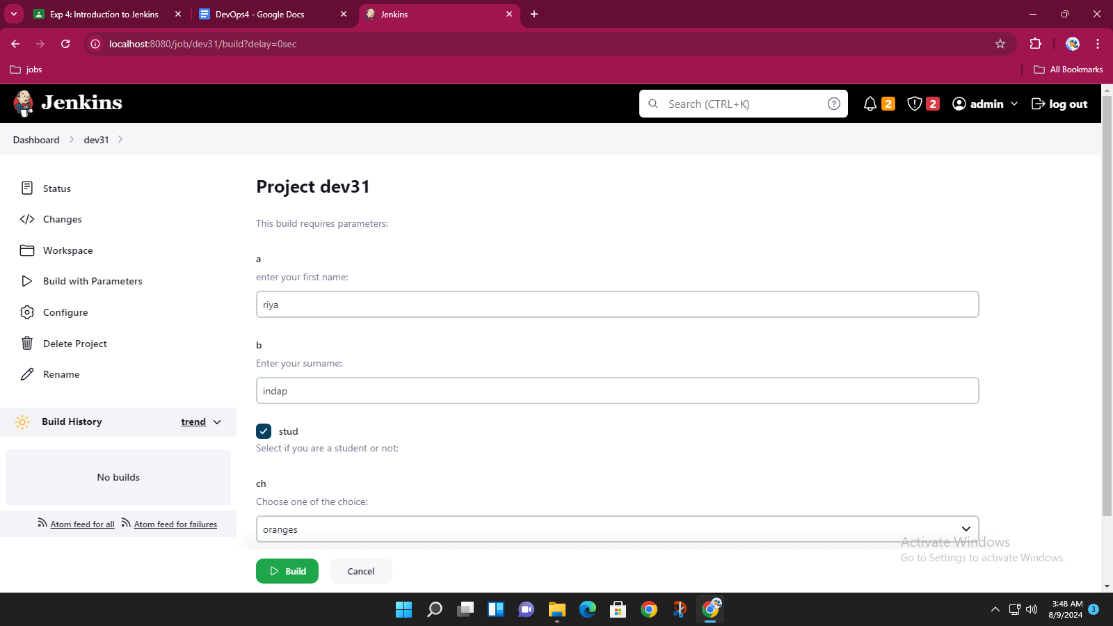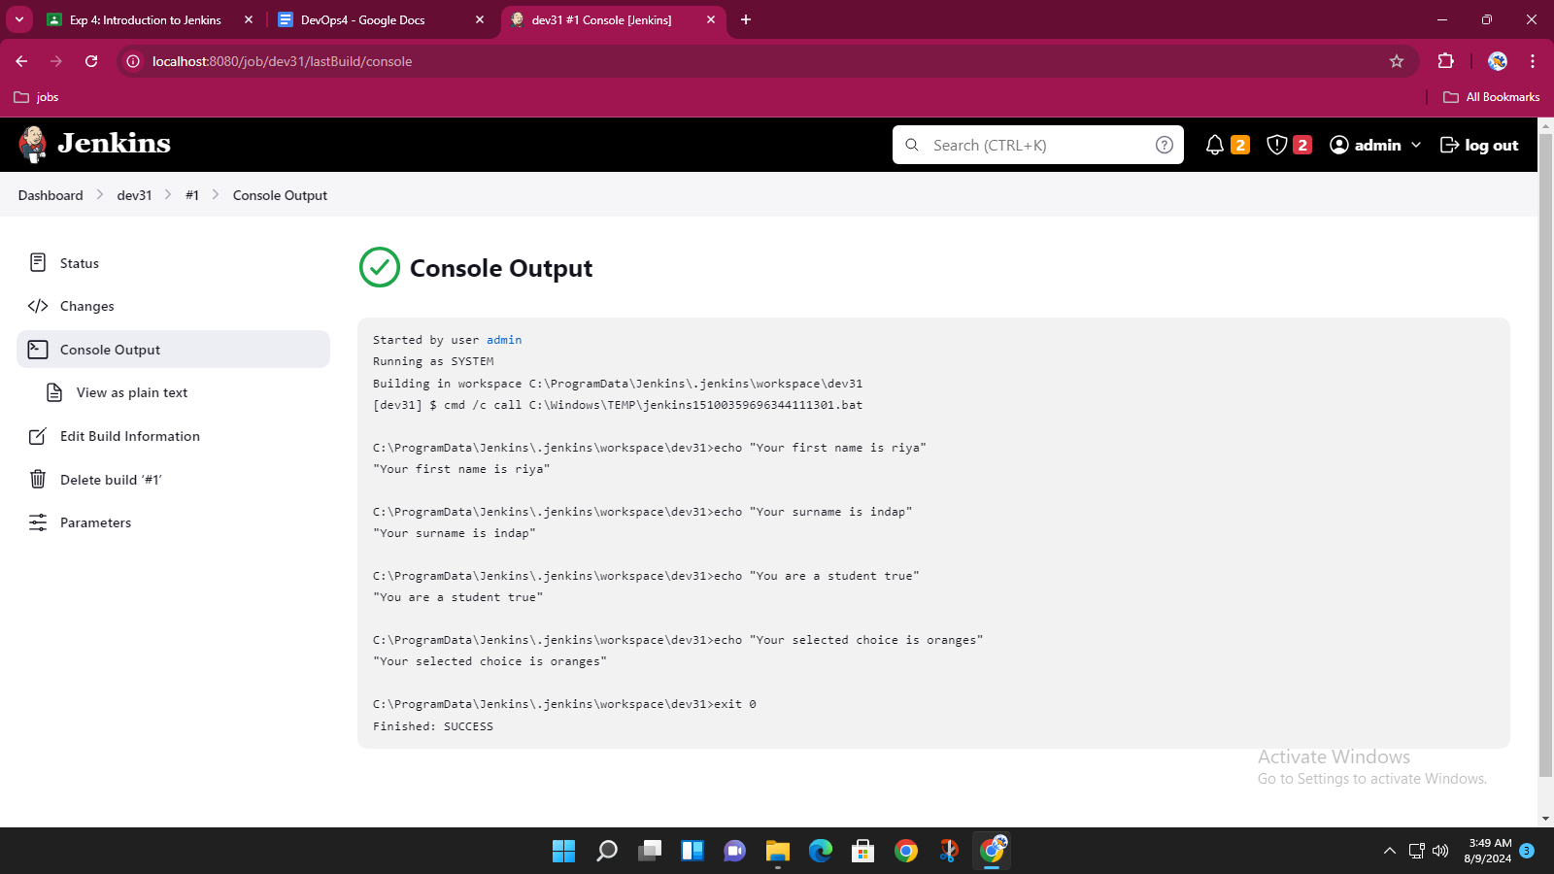

3. Java freestyle project -Hello world

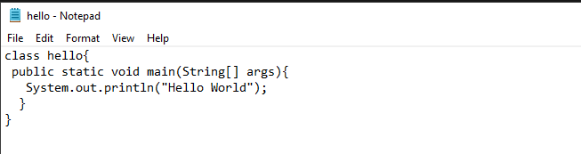

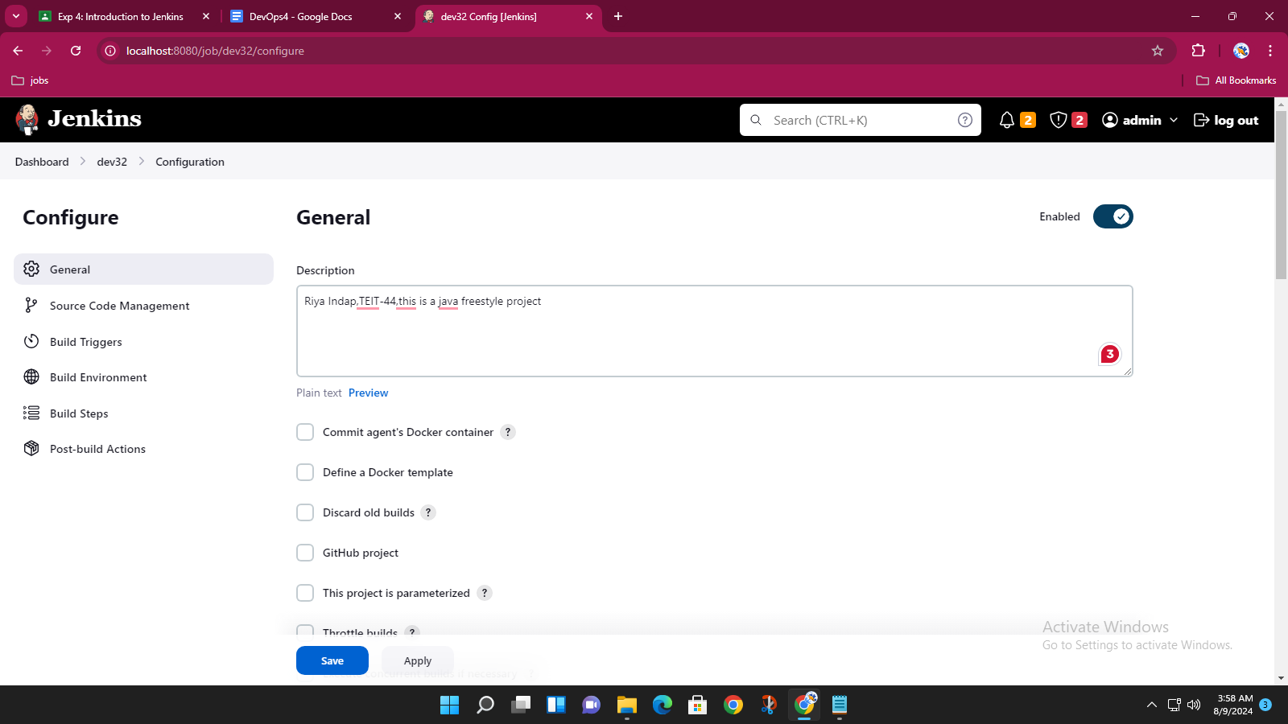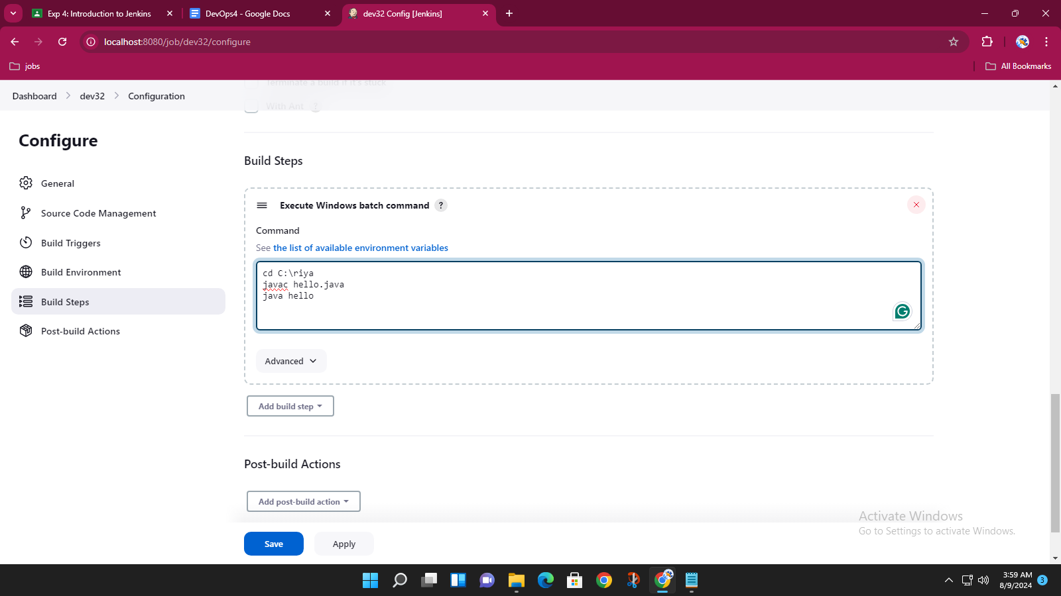

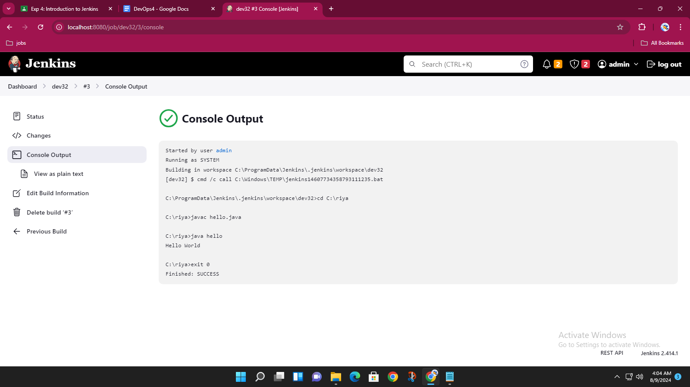

4. Java freestyle project (parameterized) – 2 String parameter